Paper Preparation for IJSSSR Publications
Primary Author 1; Secondary Author 2
¹Department of ECE 1XYZ University, New Delhi, India,
²Department of Physics, ABC University, Taiwan
Corresponding Author Email: abcdef@gmail.com
Abstract— The abstract should include a synopsis of the paper's content. Try to keep the abstract's word count under 250. Do not display equations or references in the abstract. The same-sized copy you prepared will be used to print the journal. You should print out y— our manuscript on A4 paper (21.0 cm x 29.7 cm). The margins and formatting guidelines listed below must be strictly followed. This will help us maintain consistency in the Journal's final printed copies. Please remember that as soon as the manuscript is received, it will be photographed and printed. The capacity to read the copy is crucial.
Keywords: Introduce at least five keywords, separated by a comma, in alphabetical order.
I. INTRODUCTION
The problem's nature, prior research, the paper's objective, and its contribution should all be explained in the introduction. For ease of comprehension, the contents of each part may be provided.
II. HEADINGS
The headings and subheadings, starting with "1. Introduction", appear in upper and lower case letters and should be set in bold and aligned flush left. All headings from the Introduction to Acknowledgements are numbered sequentially using 1, 2, 3, etc. Subheadings are numbered 1.1, 1.2, etc. If a subsection must be further divided, the numbers 1.1.1, 1.1.2, etc.
The font size for heading is 11 points bold face and subsections with 10 points and not bold. Do not underline any of the headings, or add dashes, colons, etc.
III. ARRANGEMENTS AND EQUATIONS
Each heading or subheading should have a first paragraph that is flush left and subsequent paragraphs that are indented by five spaces. The presentation of an equation is preceded by a colon, but it is followed by no punctuation. Every equation has a number, which is the only way to identify it in the text (e.g., (3) reads as "equation 3"). A reference [4] or an equation (3) designation should not be confused with any other numbering system you employ in your article.
IV. TABLES AND FIGURES
Diagrams and typography MUST be either computer-drafted or hand-drawn in India ink to produce a high-quality final output.
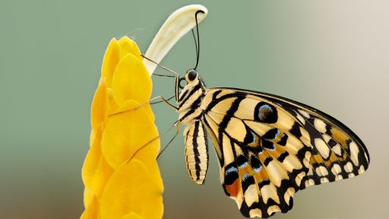
Figure 1. Table Title

Lowercase captions for figures are flush left, flush below the figure, and appear below the figure. The abbreviation "Fig." is utilised to designate a figure within the text. In accordance with their placement in the text, figures should be numbered.
Upper and lower case table captions are shown centred above the table. The word "Table" is capitalised and no abbreviation is used when referring to a table in the text.
V. CONCLUSION
There must be a conclusion section that outlines the paper's benefits, constraints, and potential applications. Although a conclusion could summarise the paper's main ideas, avoid using the abstract as the conclusion. The relevance of the work may be further discussed in the conclusion, and applications and extensions may be offered.
ACKNOWLEDGEMENTS
If desired, a section of acknowledgement can be included following the conclusion.
REFERENCES
- Casson N., “A flow equation for pigment oil suspensions of the printing ink type, In: Mill CC, editor.” 959-84. 2021
- Raptis A., Perdikis C. and Takhar H. S., “Effect of thermal radiation on MHD flow”, Appl. Math. Comput.,153,
pp. 645-649 , 2022.
- Cowling T. G., “Magnetohydrodynamics, Inter Science Publishers”. New York, 1957.
At least three recent references are needed in the manuscript for acceptance.

Mail your Manuscript to editors@ijsssr.com

